CPME President
Prof. Dr Frank Ulrich MONTGOMERY
CPME Secretary General
Mrs Annabel SEEBOHM

Athens, July 15th, 2020
Ref.: 6243

Dear President,
Dear Secretary General,

We wish to bring your attention to the recent developments regarding the monument of Hagia Sofia. As you may well know Hagia Sofia is standing strong as of 537 AD. It was completed during the reign of the emperor Justinian. It is characterised as the epitome of Byzantine architecture having a fully pendentive dome. It has served for more than a thousand years as the cornerstone of the eastern Christianity.

It was converted to a museum in 1935 by the head of the secular Turkish government Kemal Ataturk. It is a celebrated monument symbolizing religious tolerance and inclusion. It has been characterized as World Heritage site by the UN cultural agency (UNESCO) thereby gaining protection under the 1972 World Heritage Convention.

Dear President,
Dear Secretary General,

The fact that the same Turkish State has recognised the ecumenical character of the site in a greatly symbolic gesture back in 1935 (when the Turkish republic was still young, and in the same year that the first women parliamentarians were elected) was a message to the world that the Turkish republic respected the western values and wished to be part of the modern world.

Alas, the recent decision is symbolic of the opposite: the conversion of the Turkish republic into a hardcore Islamic republic with no respect for diversity and no interest in respecting its obligations deriving from international conventions; in fact no respect for international law whatsoever.

This assault in not against the Orthodox. It is not against the Christians. It is against the shared values that pertain the world and have laid the foundations for the prosperity that ensued the second world war. We, as scientists and the offsprings of renaissance have a duty to the world to raise our voices against any attempt to impose a veil of darkness over the world. We have a duty to protect our way of living which is foremost based on Principles. Principles which in the case of Hagia Sofia have also gained legal status and impose specific obligations on Turkey.

No state should be allowed to cherry-pick which legal obligations it will respect and which it will ignore. Being part of the modern world means partaking to the same duties and obligations as the rest of the world.

With this in mind:

1. We urge you to raise our voice and emphatically condemn the conversion of Hagia Sofia into a mosque.
2. Decide on specific measures against the republic of Turkey with regards medical conferences starting with suspending CPD credits to any conference that will take place in Istanbul up and until the decision to convert Hagia Sofia to a mosque is reversed.

We look forward to your leadership in protecting our shared and common values before they become irrelevant by continuous infringements

Yours sincerely,
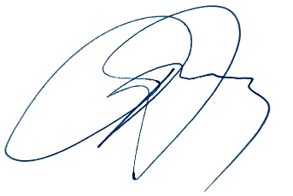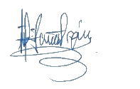
Dr ATHANASIOS A. EXADAKTYLOS (MD, PhD) Dr GEORGIOS J. ELEFTHERIOU (MD, PhD)
PLASTIC SURGEON VASCULAR SURGEON
PRESIDENT SECRETARY GENERAL

